Expense Reimbursement Form
Name and Date of Event: | 2024 Grantee Convening – September 20-21, 2024
Participant Name:
Name for Reimbursement:
Address for Reimbursement:
Contact Name:
Contact E-Mail:
Contact Phone:
Reimbursement will be by Wire Transfer or Electronic Fund Transfer, please fill out the information below. Please note that banks often charge a fee for incoming Wire Transfers and we are unable to reimburse for this expense.
Bank Name:
Bank Address:
Name on Account:
Account Number:
International Bank Swift Code (for Wire Transfer):
U.S. Bank ABA Routing Number (for Electronic Fund Transfer):
Please refer to sample check with illustration of routing number location on next page.

Sample check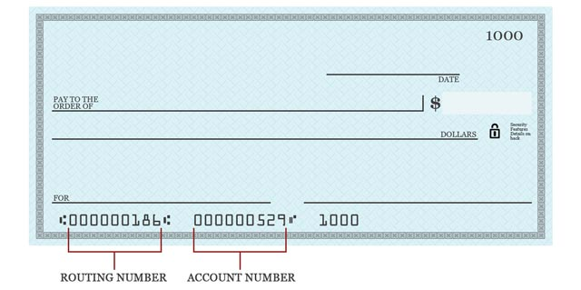

Itemized Expenses
Complete the information below and retain copies of receipts for your records.
- Reimbursement can be processed in the following currencies: USD.
PLEASE NOTE all expenses must be converted to the same currency.
- Please use xe.com for any expense that needs to be converted. Use the historical rate per the receipt/invoice date and add the rate on the invoice or in the explanation below.
- Mileage will be reimbursed at $0.67 per mile, which is the current IRS standard mileage rate for business miles driven; please provide a start and end point for mileage reimbursement.
Item/Explanation of Event | Amount of Expense | Currency Type | Account Code (Internal Use Only)
Total Amount Requested
Please send the receipts within 90 days of travel, along with the completed itemized expenses form to XXXXX XXXXX at XXXXX@merid.org
For Internal Use Only
Project Code: | Account Code: | Amount:
Approval: |  | Date Processed:

